Format of the CAE exam:
Part 1 (Interview)
The candidates are asked for personal information about themselves with simple introduction questions. The task usually lasts for 2-3 minutes and is used as an ice-breaker. The key to doing well in this part of the exam is to give a good first impression. You must speak with extended, fluent and confident answers.
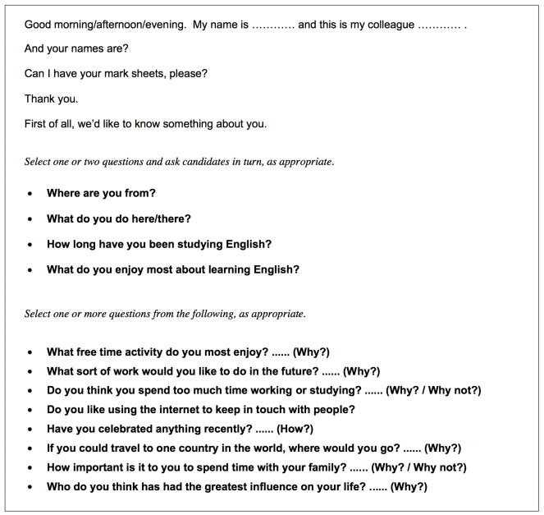
PRACTICE QUESTIONS: Starter speaking questions – (C1) for the Advanced Cambridge ESOL exam (CAE)

Part 2 (Long turn)
The candidates are to speak for one minute without interruption about 2 images (they are given a choice of 3) and also to answer two direct questions. The candidate is to compare and contrast the images, drawing on their own experience to answer the questions. They should use their own opinions to do so. The key to passing this part of the exam is to organize your speech to ensure that you incorporate complex grammar and sufficient cohesive devices. YOU MUST AVOID HESITATING AND REPEATING YOURSELF.
USEFUL INFORMATION: 10 Activities Using Images and Photos
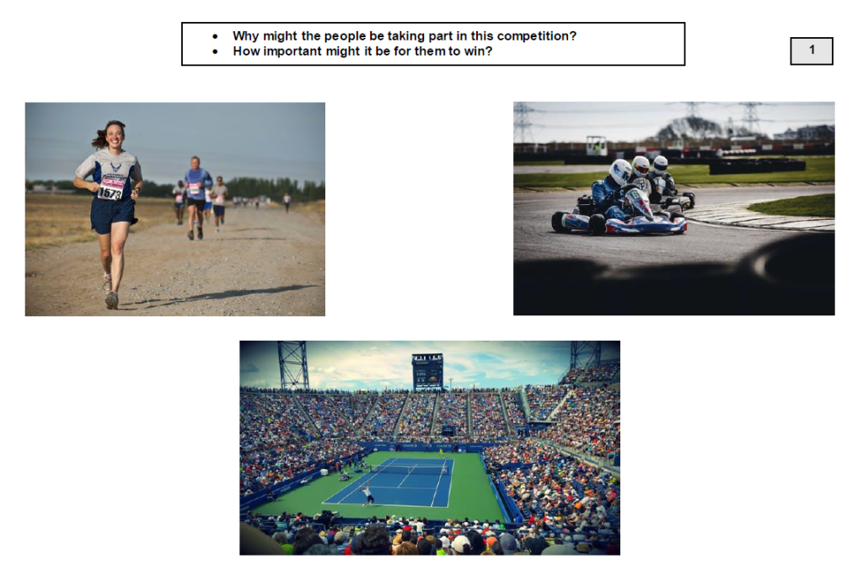

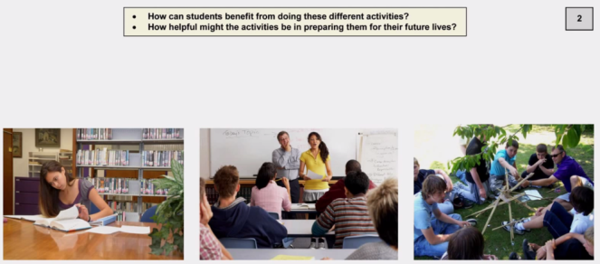

Part 3 (Collaborative task)
In this part of the exam, candidates are to interact and have a conversation for about 3 minutes. They must speak about a given situation, using their skills to initiate and respond, speculate, develop and maintain the conversation and try to negotiate an outcome. The best way to pass this part of the exam is by asking lots of questions and trying to have an informal conversation about the task. It is also easier if you purposely disagree with your partner and later come to an agreement.
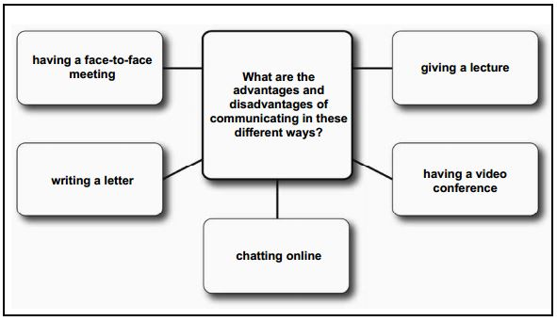
USEFUL INFORMATION: 5 activities to improve interactive communication skills

Useful phrases:
Agree
- I see your point
- I get what you mean
- We see eye to eye
- I understand your point of view
- Exactly
- That´s right!
- You took the words right out of my mouth
- I couldn´t agree more

Disagree
- No way!
- Are you serious?
- You must be joking!
- Are you pulling my leg?
- Really?
- What are you on about?
- I can´t agree with you on…

Part 4 (Discussion)
In this part of the exam the interlocutor directs the conversation to encourage the candidates to interact further. The candidates have the opportunity to give and exchange their ideas, express opinions, justify themselves and also to agree and disagree with each other. The most important part of the last task is to show a willingness to speak and also to develop topics and make them more interesting. You must express your personal opinions.
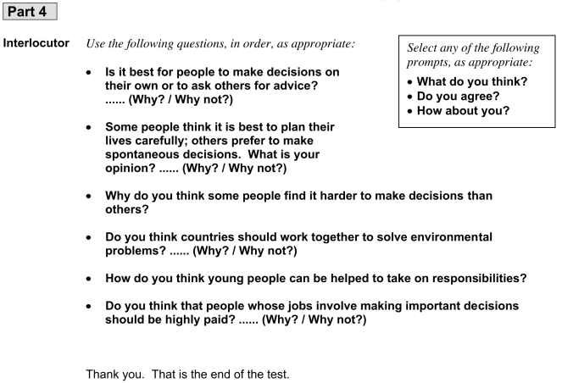
USEFUL INFORMATION Advice for speaking better during Cambridge oral exams

Useful vocabulary:
- In my opinion, …
- In my eyes, …
- To my mind, …
- As far as I am concerned, …
- Speaking personally, …
- From my point of view, …
- As for me / As to me, …
- My view / opinion / belief / impression / conviction is that …
- I hold the view that …
- I would say that …
- It seems to me that …
- I am of the opinion that …
- My impression is that …
- I am under the impression that …
- It is my impression that …
- I have the feeling that …
- My own feeling on the subject is that …
- I have no doubt that …
- I am sure / I am certain that …
- I think / consider / find / feel / believe / suppose / presume / assume/reckon that …
- I hold the opinion that …
- I dare say that …
- I guess that …
- I bet that ….
- I gather that …
- It goes without saying that …

